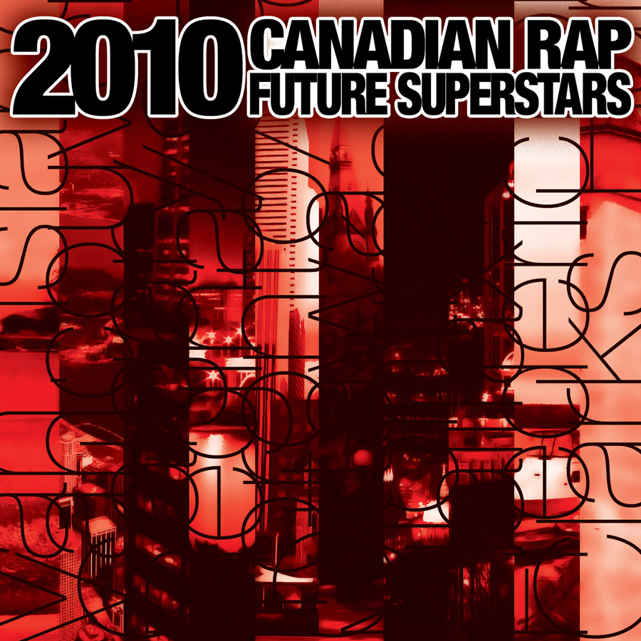
For Immediate Release
December 29, 2009
Media Contact:
Brockway Ent – www.brockwayent.com
Full Album Information including download link, album cover, track listing, etc :
http://www.brockwayent.com/brockwayent2010.html

Ottawa, ON – In continuing with their annual holiday tradition, Brockway Entertainment has compiled their 23 favourite Canadian rap tracks of 2009 and packed them all onto one album. The ‘2010 Canadian Rap Future Superstars’ compilation is non-profit initiative aimed at providing exposure for up-and-coming Canadian rap artists. The album can be downloaded and ordered for free from www.BrockwayEnt.com .

The diverse 2010 compilation features 34 Canadian artists and 24 Canadian beatmakers, spanning 11 Canadian cities including obsolete corners such as Comox, BC and Clarks Harbour, NS. Brockway Entertainment increased its community collaboration in 2009 as Mantrakid (80Bit.com) provided the album design, and DJ Sage of CFRO’s ‘Urban Renewal Project’ provided a choice cut.

The 2010 track listing features:
01 - Manafest (Toronto) - Free - www.manafest.net
02 - Monark (Fredericton) - Playground feat Phakt - www.myspace.com/mistermonark
03 - Hellafactz (Halifax) - Thought Of U feat Yvette Jarvis & Michael Beals - www.hellafactz.org
04 - Relic (Toronto) - Just The Day feat Saukrates - www.myspace.com/relictheoddity
05 - Drumbo = Def3 & Factor (Regina & Saskatoon) - Take Me Higher - www.def3.ca / www.sideroadrecords.com
06 - Mantrakid (Comox, BC & Calgary) - My Calling - www.neferiu.com
07 - Ricca Razor Sharp (Calgary & Clarks Harbour, NS) - Rampage - www.riccarazorsharp.com
08 - Iron Lion (Calgary) - Take a Breather feat King Lou - www.impirical.ca
09 - Joe Buck (Halifax) - Who We Are feat Jay Bizzy - www.facebook.com/JoeBuck902
10 - Cale Sampson (Toronto) - C-A-L-E - www.calesampson.com
11 - Chris Quotes (Toronto) - Where's the Cash at - www.myspace.com/puffycoates
12 - Eye2Eye (Montreal) - Wing Man - www.eye2eyeproductions.com
13 - KG (Ottawa & Scotia) - Megatron - www.myspace.com/intkg
14 - Solid Mas (Toronto) - Ridin Dirty feat Nova Kane & Priceless - www.myspace.com/solidmas
15 - Rah Zemos (Toronto & Beirut) - Bad Apples - www.rahzemos.com
16 - HeatWave (Vancouver) - Bills To Pay (CFRO 'Urban Renewal Project' Choice Pick) - www.killawattrecords.ca
17 - Josh Martinez (Vancouver) - Responsibility feat Evil - www.joshmartinez.ca
18 - Brass Tackz (Vancouver) - Broken Promises - www.myspace.com/brasstackz
19 - Ghettosocks (Halifax) - R. Kelly's Ghostwriter Skit feat Jordan Croucher - www.ghettosocks.com
20 - Dan-e-o (Toronto) - Yesterday - www.dan-e-o.com
21 - Tru Paz (Toronto) - My Lady - www.tru-paz.com
22 - Empire ISIS (Montreal) - Four In The Morning - www.empireisis.com
23 - Shaun Boothe (Toronto) - Music Man feat Amanda Diva - www.myspace.com/shaunboothe

The compilation began in 2003 as a handful of burnt CDs made by executive producer Brockway Biggs for friends & family during the winter holidays. In 2005, Biggs made extra copies, which were sent to campus radio and other media outlets. Since then, the success of the compilation has continued to grow, while annually topping the campus radio rap charts.

“As an artist, I understand the struggle”, states Biggs. “For years I wrote reviews and features via HipHopCanada.com to provide exposure for Canadian rap artists. By 2005 I was starting to run short on time, so I explored other ways to give back to the community. That’s when the compilation series really began to take shape.”

Artists wishing to be considered for next year’s compilation are encouraged to submit their music via SonicBids ( SonicBids.com/CanadianRapFutureSuperstars ).

Brockway Entertainment was impressed by several independent Canadian rap releases in 2009, and is glad to have the opportunity to share with you some of their favourite tracks. Brockway Entertainment hopes you had a wonderful holiday season and you enjoy their 2009 choice selections.

Artist: Various Canadian Artists
CD Title: 2010 Canadian Rap Future Superstars
Catalog #: BROCK-011
Release Date: January 5, 2010
Website: www.BrockwayEnt.com
Label: Brockway Entertainment – www.BrockwayEnt.com
Distributor: Free online

###

