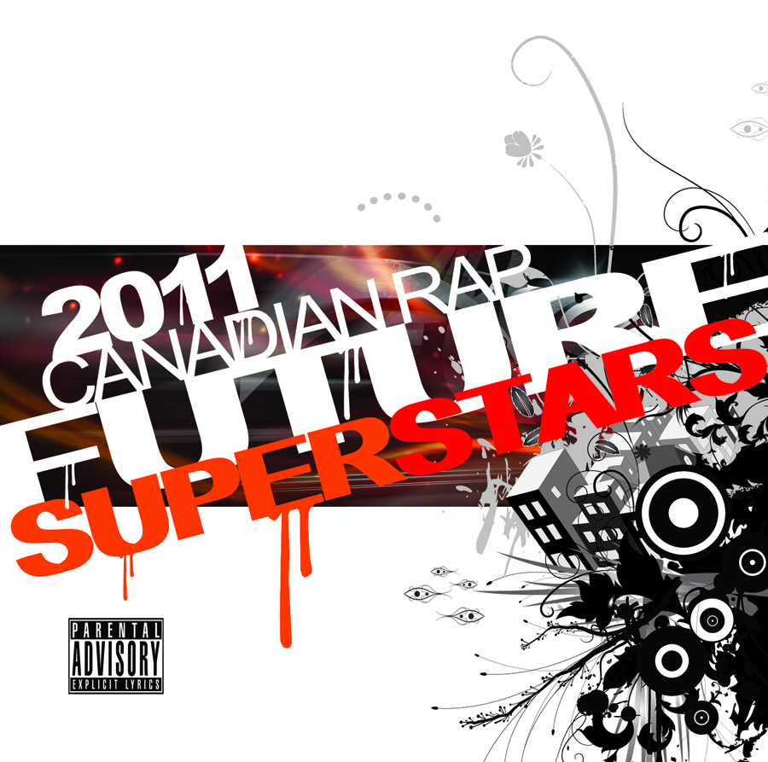
Artist: Various Canadian Artists
Title: 2011 Canadian Rap Future Superstars
Category:
Hip-Hop / Urban / Canada / New Releases
Region: Canada

Release Date: January 4, 2011
Program # BROCK-012

Marketing & Media Contact:
www.brockwayent.com

It's the holiday season, so we're back with another compilation chock full of our favourite Canadian rap tracks from the past year. It features 34 Canadian artists, 8 Canadian DJs and 17 Canadian beatmakers, spanning 10 Canadian cities from Halifax, NS to Victoria, BC.

2011 Brockway Ent Canadian Rap Future Superstars

Big thanks to Nayles (NaylesDesign.com) for the cover art and Asher Media Relations (AsherMediaRelations.com) for the publicity assistance. And to anyone who provided used bubble mailers & jewel cases.

I received more submissions than ever this year, so I hope you enjoy my picks.

The track listing consists of:
01 - DJ Jayceeoh (North America) - GO OFF! (dirty) feat Scratch (Of the Roots), Skratch Bastid, Shiftee, Hedspin, Dopey, Mat The Alien, Marvel, I-Dee, Spryte, Excel & Wundrkut - www.jayceeoh.blogspot.com
02 - Alex Dimez (Toronto) - All Out (remix) (dirty) - www.handsolorecords.com
03 - JD Era (Toronto) - You Know This (radio edit) - www.th1rt3en-mixtape.com
04 - Pip Skid (Winnipeg) - Back Rub Rap (dirty) feat Yy & Silly Willy - www.foultone.com
05 - Langdon Auger (Victoria) - The Drive Through (dirty) - www.langdonauger.com
06 - Perfeck Strangers (Toronto) - Work To Do (radio edit) feat Drake - www.perfeckstrangers.com
07 - Plex (Edmonton/Toronto) - Spare Change (dirty) feat Rellik, Touch & Leemai - www.iamplex.com
08 - Indelible (Vancouver) - Gets Me High (clean) feat Blaming Taylor - www.indeliblehiphop.com
09 - The Extremities (Halifax/Toronto) - Lost Souls (clean) - extremities.bandcamp.com
10 - D-Sisive (Toronto) - I Love A Girl (Grizzly Bear Hijacked) (radio edit) - www.d-sisive.com
11 - Ski (Toronto) - 4Evr Young (Dj Unknown Remix) (clean) - www.myspace.com/magneticaquarian19
12 - TRP (Windsor) - Execution (clean) - www.trpemcee.com
13 - Magnum K.I. (Winnipeg) - Sleep (clean) feat Süss - www.magnumki.com
14 - e.d.g.e. (Vancouver) - Target Practice (clean) feat Dave Ryan - edge.bandcamp.com
15 - D-Sisive (Toronto) - West Coast (clean) - www.d-sisive.com
16 - Louwop (London/Toronto) - For the Love (clean) - www.louwop.com
17 - Metawon (Calgary/Vancouver) - Joy + Pain (dirty) feat Just B - www.myspace.com/meta1
18 - Gee Wunder (Toronto) - Pressure Busts Pipes (dirty) feat Mad Child - www.geewunder.com
19 - Mullet N Steps (London) - Can't Have Me (radio edit) - www.youtube.com/Mdubbleo
20 - Baf (Moncton) - Believe me (remix) (clean) feat iNTUiT - www.soundclick.com/bigbaf
21 - Underground Realroad (Montreal) - Be Who U-R (dirty) feat Miss Tee - myspace.com/UndergroundRealroad
22 - Nayles (Moncton) - People Playin' (dirty) - www.nayles.ca

Season's blessings,
Brockway Biggs

